Aberdeen house care limited – (“the Company”)

**Company Registration Number: 07658860**

I, Laura Stewart of Business Helpline Group Limited, confirm that I am qualified as an Insolvency Practitioner to act as Liquidator of the above company and consent to act as such.

I further confirm that I hold the security required under the insolvency legislation.

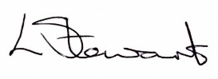

Laura Stewart

Dated: 5 January 2024